Crane training

new zealand limited

Crane operator licencing

Certificate of Competency

Published by
Crane Training New Zealand Ltd

Issued: 7 March 2017

Contents
1. Introduction 3
2. Overview 4
3. Crane Association of New Zealand Inc Responsibilities 4
4. Crane Training New Zealand Ltd Responsibilities 5
5. Oversight Working Group 5
6. Terms of Reference and Scope 6
7. Levels of licence 7
8. Phases of the process 7
Phase 1 – Unit Standards 8
Phase 1 8
Phase 2 – Full Qualification 8
Phase 3 –Online knowledge Assessment 9
Phase 3 9
Phase 4 –Practical Competency Assessment 9
Phase 4 9
Phase 5 – Development of Crane License 9
9. Considerations 10
10. References 10

Figures
Figure 1: Levels of Licence 7
Figure 2: Licencing Phases 7

Introduction
In New Zealand, high-risk industries like scaffolding, construction blaster, powder-actuated tools, and diving are all required to have Certificates of Competence under the Health and Safety in Employment Regulations 1995 Part 3. (Ministry of Labour, 1995)
The crane industry is considered a high-risk industry by WorkSafe New Zealand. This perception is not based on statistical data but on the impact that a crane accident has on life and limb.
New Zealand training requirements are based on:
- The lifting and access industry is one of a few industries that has unit standards as the minimum qualification.
- WorkSafe NZ recommends full qualifications and competency assessment to meet the requirements of the Health and Safety at Work Act 2015 and its associated regulations 2016.
As a responsible industry, this should be the aim of the crane industry and the proposed Certificate of Competency licencing process would achieve this aim.

Overview
In the later stages of 2015, the association were advised that operating a crane was considered a high-risk occupation and that WorkSafe NZ had the intention of licencing all high-risk occupations by 2018. The Crane Council considered this at the February 2016 Council meeting and recommended supporting proactively a licencing process if WorkSafe NZ would endorse such an approach. The association requested clarification from WorkSafe NZ in a letter dated 29th February 2016 on whether licencing was going to happen and if it did would they endorse the association putting in place a licencing programme.
WorkSafe responded in a letter dated 13 April 2016 endorsing the associations lead in setting up a licencing process and offering technical assistance in the development of the process.
Preliminary work had been done with the development of a framework and a discussion document.
On the 1st October 2016, a Terms of Reference and Scope document for the development of the licencing process was prepared with the aim to have an external provider act as the programme manager.
An approach was made to Paul Stock of Qualserv. The Terms of reference and scope were forwarded to him and he responded with a proposal on the 18th October 2016 which was tabled at the November Council Meeting. It was determined that this was going to be an expensive exercise and an alternative was to be investigated.
This document has been designed as a strategic high level planning document for the licensing (CoC) of a crane operator (includes dogman)
Its intention is to provide a basis on which the CoC can be introduced over time through a series of phased milestones.

Crane Association of New Zealand Inc Responsibilities
The Crane Association of New Zealand Incorporated has the overall responsibility of approving the project and allocating responsibility of the day to day management to Crane Training New Zealand Ltd.

Crane Training New Zealand Ltd Responsibilities
Crane Training has several responsibilities in the initial planning of this project. These would include but are not limited to:
- Writing the project Terms of Reference and Scope
- Establishment of the Oversight Working Group
- Working with Crane Association and Working Group to establish license administration
- Apply for recognition from WorkSafe to issue Certificates of Competence under Sect 28 of the HSE Regulations 1995. (Ministry of Labour, 1995)
- Commence generation of database of licence holders
  - Data gathering ancillary activities
    - Drive education
    - Promotion of qualifications
    - Notification of safety alerts
- Determine fees in accordance with Schedule 2 of the HSE Regulations 1995 (Ministry of Labour, 1995)
- Establish type and format of Certificate to be issued
- Determine core competencies for phase three in conjunction with Skills and the Crane Association.
- Identify an online assessment app
Crane Training New Zealand CEO will be responsible for the day-to-day management of the CoC and will be the liaison for the Oversight Working Group.

Oversight Working Group

As this is an industry-wide initiative, it is proposed that an independent body be established to provide oversight through the development phases of the project.
The following organisations are indicative of the industry stakeholders that would be invited to participate:
- Mandatory
  - Crane Association of New Zealand Inc
(Mobile, Crawler, Tower, Truck Loader Crane and Gantry Representatives)
  - Crane Training New Zealand Limited
  - WorkSafe
  - Skills Organisation
- Optional
  - Ports and Stevedoring Association
(Ships Cranes, Container Cranes Representatives)
  - Maritime New Zealand
The Oversight Working Group (OWG) would be responsible for providing guidance on establishing the Certificate of Competency (Crane Operator Licencing) and would work to a project Terms of Reference and Scope
The basic mandate would be to determine the triggers that transition the phases to the next level. Some of those triggers may include but is not limited to:
  - Changes to qualification levels;
  - Changes to legislation;
  - Reflection of industry requirements;
  - Changes in technology; and
  - Improvements in assessment capability.

Terms of Reference and Scope
A Terms of Reference (ToR) and Scope that will act as a guideline for the Oversight Working Group will need to be developed that would include project milestones and potential timelines.

Levels of licence
Licencing must recognise the levels of qualification and competency of the crane operators. This cannot be achieved through a single licence process. For example, competency and qualifications vary across a broad spectrum from trainee to an experienced advanced operator.
One potential pathway could be as follows:

Figure 1: Levels of Licence
The scope to be determined by Working Group to address process of achieving a license.

Phases of the process

The key to a licencing process being successfully implemented is to obtain the buy-in of the industry.
A stepped process creates the least amount anxiety from employers and operators and enables a thorough planning and process development.
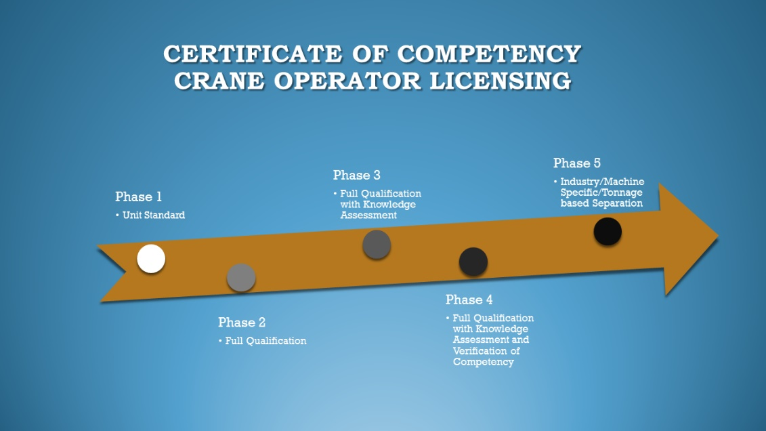
Figure 2: Licencing Phases
Figure 1 demonstrates a possible pathway for the licencing process.

Phase 1 – Unit Standards
The Approved Code of Practice for Cranes (2009), Part 4 (Department of Labour, 2009) details the requirements for unit standards as being the minimum qualification needed to operate cranes within New Zealand (Annex A). As this is the existing requirement for crane operators, this should be the starting point.
Currently, individual unit standards are treated as casual credits by the ITO and the crane industry has a high use of unit standards versus full qualifications. Operators holding individual unit standards are not considered fully qualified and therefore it is in the interests of the industry to move to a full qualification as the minimum standard.

Phase 1
An operator holds unit standards as per Approved Code of Practice for Cranes (2009), Part 4 (Department of Labour, 2009)

Phase 2 – Full Qualification
A full qualification includes a crane unit standard as well as a demonstration of knowledge of health and safety, regulations and legislation, general skills for the crane industry and the application of safe work practices. (The Skills Organisation, 2015) It should be the aim of the Association to upskill every operator to a full qualification.

Phase 2
An operator holds a full qualification such as a National Certificate in Cranes.

Phase 3 –Online knowledge Assessment
Crane Operators to hold a license would undertake an online knowledge assessment that will determine if there are any gaps in their knowledge and will act as an indicator for retraining.

Phase 3
An operator holds a full qualification such as a National Certificate in Cranes and has passed an online knowledge assessment at a set period.

Phase 4 –Practical Competency Assessment
This phase introduces the first of the practical competency assessments which would prove an operator:
- Post qualification competency
- Competency from proven experience
- Advanced skill levels – move onto larger and a more complex crane
An operator would complete a practical competency assessment only after passing their online knowledge assessment.

Phase 4
An operator holds a full qualification such as a National Certificate in Cranes and has passed an online knowledge assessment and practical competency assessment at a set period.

Phase 5 – Development of Crane License
To be determined. Licence Endorsements for advanced operation (F Endorsement Drivers License Example).

Considerations

To enable the licencing process to proceed we need to be cognisant of changes to legislation and regulations that are coming up. Pressure Equipment, Cranes and Passenger Ropeways Regulations 1999 (Department of Labour, 1999) and Approved Code of Practice for Cranes, 2009 (Department of Labour, 2009) are two rewrites that are programmed.

References
Department of Labour. (1999). Pressure Equipment, Cranes and Passenger Ropeways Regulations 1999. Retrieved from Worksafe New Zealand: http://www.worksafe.govt.nz/worksafe/information-guidance/all-guidance-items/pressure-equipment-cranes-and-passenger-ropeways-regulations-1999-a-general-guide-to-the-health-and-safety-in-employment
Department of Labour. (2009, November). Cranes - Approved Code of Practice (ACOP) 3rd Edition. Retrieved from Worksafe New Zealand: http://www.worksafe.govt.nz/worksafe/information-guidance/all-guidance-items/acop-cranes
Ministry of Labour. (1995). Health and Safety in Employment Regulations 1995. Retrieved from New Zealand Legislation: http://www.legislation.govt.nz/regulation/public/1995/0167/19.0/DLM202257.html
The Skills Organisation. (2015). Qualifications. Retrieved from Crane Association of New Zealand Inc: http://www.cranes.org.nz/uploads/2/0/5/7/20572552/new_zealand_certificate_crane_operations.pdf

