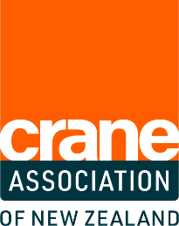
CRANE AWARDS 2023
ENTRY FORM

AWARD CATEGORY: Crane Training Company
of the Year
Are you a crane company who prides itself on providing outstanding training to your employees? Gain the recognition you deserve for taking the lead and training the next generation of operators.
Entry Criteria:
The nominated company must:
- Have a crane trainee currently employed with them OR
- Had a crane trainee complete a crane qualification with them in the last
18 months.
Judging Criteria
The nominated company must demonstrate:
- That high quality trainee support is provided in the workplace
- How training and professional development is promoted in the workplace
- How trainees are provided with an effective training environment
- Exceptional commitment to industry training
Entrant contact details
Company name
Address
Contact person
Mobile
Email

Entry submission
How many crane trainees has your company supported in the last 5 years?

How many years has your company been taking part in formal crane industry training?
Describe your company’s process for training new crane operators:
What does your company do (regarding training) that makes it stand out from the other crane companies?
Describe how training benefits your company:
Why do you feel your company should win this award?
Name of trainee who is currently completing their qualification or has done so in the last 18 months:

Add any photos, training plans, or supporting evidence that you feel will support your application for this award.

Declaration

☐ I confirm the information is true and accurate and I have read and understood the Terms and Conditions.
☐ I acknowledge my employer may be contacted as part of the application process.
Signed
Name
Date

