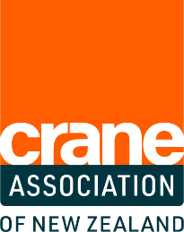
CRANE AWARDS 2023
ENTRY FORM

AWARD CATEGORY: Crane Trainer of the Year
Do you know a trainer who shows outstanding commitment and support to crane trainees? Nominate them now to give them the recognition and prestige they deserve.
Entry Criteria
The nominated trainer must:
- Be a registered crane workplace assessor with Skills / Te Pūkenga
- Currently be training a trainee registered with Skills / Te Pūkenga, or
- Have had a trainee complete their qualifications through Skills / Te Pūkenga in the last 12 months.
Judging Criteria
The nominated trainer must:
- Demonstrate a high level of ongoing support for trainees
- Demonstrate commitment to and passion for delivering excellent industry training
- Have shown initiative to try and improve systems to cater for trainee needs
Contact details - nominee
Full name
Mobile
Email
Address

Contact details - nominator
Full name
Mobile
Email
Address
Entry submission:

How many trainees have you / the trainer supported?

How many years have you / the trainer been taking part in cranes industry training?

Describe how you / the trainer supports and encourages trainees:

What motivates you / the trainer to take part in crane industry learning:

Why do you think you / this trainer should win this award?

Declaration

☐ I confirm the information is true and accurate and I have read and understood the Terms and Conditions.
☐ I acknowledge my employer may be contacted as part of the application process.
Signed
Name
Date

