Crane Association of New Zealand (Inc)

PO Box 12013, Wellington,6144 | 21 Fitzberbert Terrace, Thorndon, Wellington Telephone: 04 473 3558 | Email: info@cranes.org.nz | Website:www.cranes.org.nz
higher standards - safety first

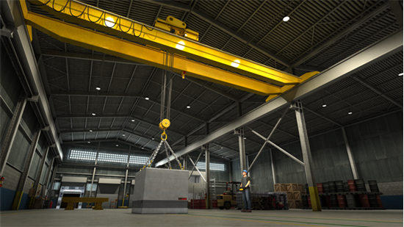

Crane Association of New Zealand
Position Paper

Safe Use of Gantry Cranes

Author: Crane Association of New Zealand
Date: 2 July 2019
CANZ PP-005

Table of Contents

Contents
1. Crane Association Position 3
2. Background 4
1.1. Purpose 4
1.2. Application 4
2. Common Accidents 4
3. Key Personnel Involved in Lifting Operations 5
3.1. Management 5
3.2. Crane Operator 5
4. Visual Checks 6
5. Rigging Methods 10
6. Operational Safety 12
6.1. Safety Considerations 12
6.2. Tandem Lifting 17
6.3. Maintenance 17
7. Use of Special Lifting Attachments 18
8. Environmental Conditions 19
8.1. Rain 19
8.2. Thunderstorms 19
8.3. Strong Winds 19
9. Documentation 19
Further Information 20
References 20

Figure 1 Overhead Crane Figure 2: Portal Crane 4
Figure 3: Common Accidents 5
Figure 4: Rigging Checks 10
Figure 5: Rigging Methods 12
Figure 6: Safety Considerations 18
Figure 7: Special Lifting Attachments 19

Disclaimer and Copyright
This Crane Association of New Zealand (Inc) Position Paper has been compiled for general information only, is not to be considered as a substitute for professional advice, and should not be treated as an exhaustive statement on the subject. The Crane Association of New Zealand (Inc) accepts no responsibility for the accuracy, completeness or currency of the material included in this Position Paper.
Users of this Position Paper are encouraged to obtain professional advice and to exercise their own skill and care in relation to any of its material.
The Crane Association of New Zealand (Inc) disclaims any and all liability or responsibility for any loss or damages arising out of any use of, or reliance on, this Position Paper.
This Position Paper is copyright. Readers may use and reproduce this material in an unaltered form only for non-commercial use within their own organisation.

Crane Association Position

It is the position of the Crane Association of New Zealand (Inc.) that:

Overhead Gantry crane design, manufacturing, and testing are regulated by standards, safety regulations and industrial codes of practice. Numerous modern technology and materials are applied and used on the Overhead Gantry cranes by crane manufacturers to make sure these sophisticated, state of the art machines are safe to operate under different conditions.
Overhead Gantry crane operators need to be familiar with the behaviour of the crane and follow manufacturer’s instructions to perform safe lifting operations with them.
CANZ recommends that all operators of Overhead Gantry cranes undertake New Zealand Certificate qualifications training which includes technical and theoretical information competency assessment and familiarization training including practical demonstrations that should be conducted under supervision.
However, the Approved Code of Practice (ACOP) for Cranes states “ all persons operating or working with a crane must hold the applicable unit Standard as a minimum”. Since this was written in 2009 there have been upgrades to Unit Standard training and it is a pre-requisite of NZQA Unit Standard 3800 V6 that NZQA Unit standard 30072 is now achieved. With these 2 Unit standards an operator should be competent to operate an Overhead Gantry crane in the workplace including lifting and securing loads without the need for a full New Zealand Certificate. If an operator can attest that he has relevant experience for slinging and rigging loads then achieving NZQA unit standard 3800 is sufficient to operate an overhead gantry crane to lift and place regular loads.

Background

“Gantry Cranes” is a collective name given to cranes that generally have an overhead beam as the main part of their structure. The two main types of gantry crane are portal and overhead. (Crane Association of New Zealand Inc, 2015) Gantry and portal cranes are used widely for material handling, particularly in the engineering, manufacturing and port industries. Safe operation of such cranes requires operators to have the knowledge and competence to avoid accidents.

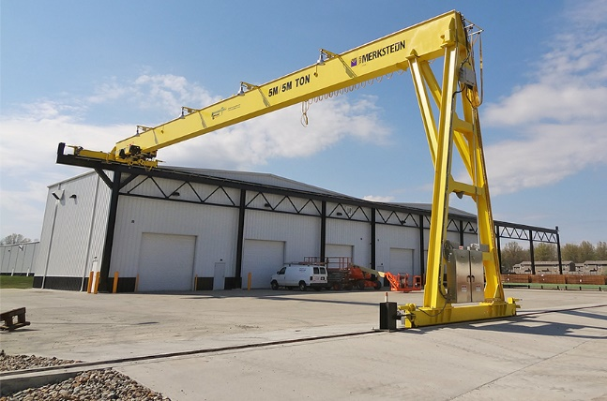
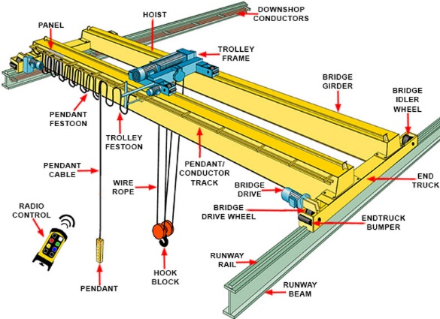

Figure 1 Overhead Crane Figure 2: Portal Crane

Purpose
The purpose of this position paper is to advise on what the crane industry expects of a gantry operator to safely operate gantry cranes on a worksite.

Application
This position paper is intended to be used by crane operators and supervisors to promote safe lifting operations in the handling of gantry cranes.

Training and Assessment
The Approved Code of Practice for Cranes (2009) Part 4 states that Unit Standard 3800 is the minimum requirement to operate a gantry crane. However, since this document was written the qualifications have undergone significant review.

Level 3 qualifications which include Unit Standard 3800 have been adjusted to setup a pathway for new entrants into the industry without excluding those persons already in the industry that have yet to undertake a qualification to validate their experience. It also took out the requirement to complete Unit Standard 3789 ( Sling varied regular loads and safely direct a crane during crane operations.) which cannot be assessed on a gantry crane (cannot be slewed).

Unit Standard 30072 has been designed to provide a person with theoretical knowledge that can be applied to a practical assessment in a classroom environment. This is a level 3 14 credit course.
The Level 3 pathway is as follows:

Unit Standard 30072 (Demonstrate and apply knowledge of slinging regular loads safely) or demonstrate equivalent knowledge and skills.

Unit Standard 3800 (Use a radio remote or pendant controlled gantry crane to lift and place regular loads)

To demonstrate equvalent knowledge and skills to achieve Unit Standard 30072, the employee must demonstrate that they have prior knowledge and experience slinging and rigging loads either with an attestation from their employer or by recorded experience in the form of a logbook or similar.

Common Accidents
Most accidents related to gantry cranes occur during the lifting activity. The consequences of an accident can be serious, and fatal at times. Adopting the right method and using the right equipment will greatly minimise potential accidents during lifting operations.

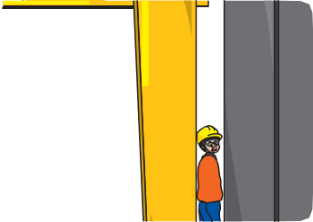

Overloading Caught in between a moving gantry crane
And structure/ objects/ fixed obstruction

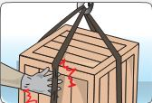

Caught in between load and lifting gear Falling load to duse to insecure rigging
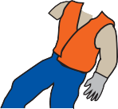

Hit by moving or swinging loads

Figure 3: Common Accidents

Key Personnel Involved in Lifting Operations
The key personnel in lifting operations includes the following duty holders:

Management

Crane owners and managers of gantry cranes must be fully aware of their responsibilities under the Health and Safety at Work Act 2015 and also should also be aware of their requirements to:
- Ensure operators hold the appropriate qualifications and deemed competent for the crane in use, (Crane Association of New Zealand Inc, 2015); and
- Maintain the crane properly and retain appropriate maintenance records (Ministry of Business, Innovation and Employment, 1999)

Crane Operator
Crane operators must be fully aware of their responsibilities under the Health and Safety at Work Act 2015, (Ministry of Business, Innovation and Employment, 2015)
and it is the crane operators responsibility to:
- Appropriately plan lifts
- Operate the crane safely
- Carry out regular checks of the crane to ensure that it is kept in a safe operating condition; and
- Record and report all defects/faults as per company procedures.

Visual Checks
The following required checks are non-exhaustive. Crane operators must conduct visual checks to ensure the crane is in working condition, and test all limiting and indicating devices under no load condition before the start of every shift. All observations must be recorded in a log book or organisation’s checklist(s) according to work processes at the workplace. Report any defects found to your supervisor immediately. See Figure 4 for types of visual checks.
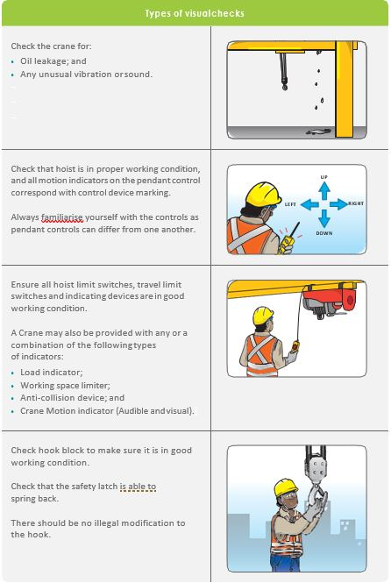

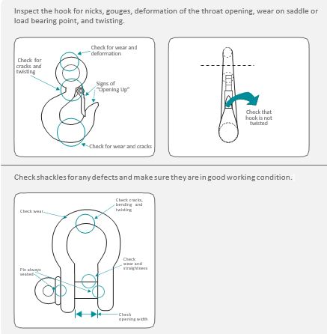

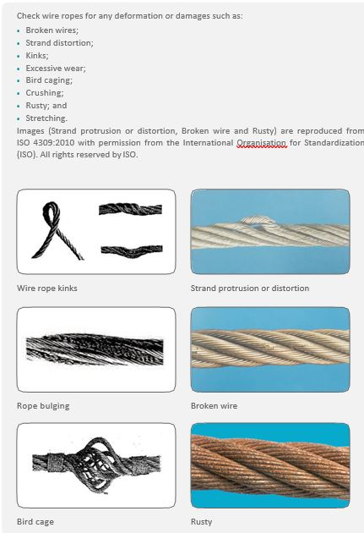

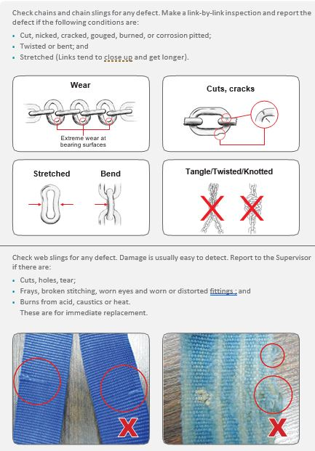

Figure 4: Rigging Checks

Rigging Methods

Accidents due to rigging can often be traced back to a lack of rigging knowledge by the dogman or operator.
The operator must know the following:
- the crane Safe Working load (SWL) must be clearly displayed in a location that is legible to the crane operator when working the crane,
- the safe working load limit of the lifting gear; and
- that the the laod to be lifted is less than the SWL.

When the weight and capacities are established, the dogman or operator must then use the proper methods to rig the load so that it is stable.
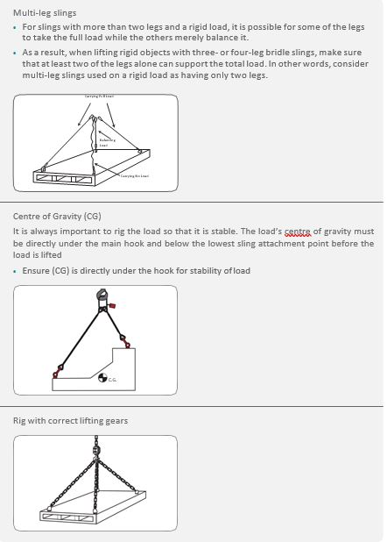

More information can be found in the Code of Practice for the Safe Use of Lifting Equipment.
Figure 5: Rigging Methods

Operational Safety

Safety Considerations
This section highlights several safety considerations when operating gantry cranes.

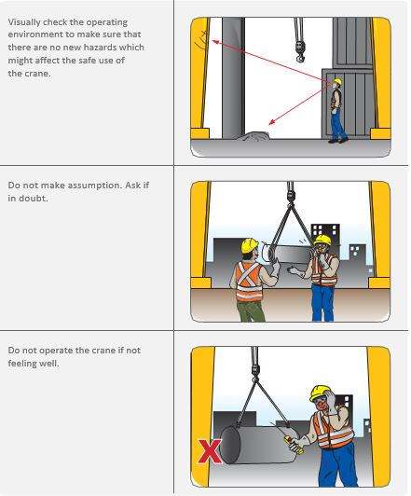

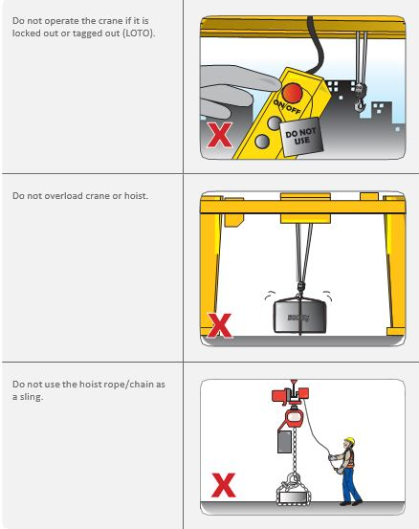

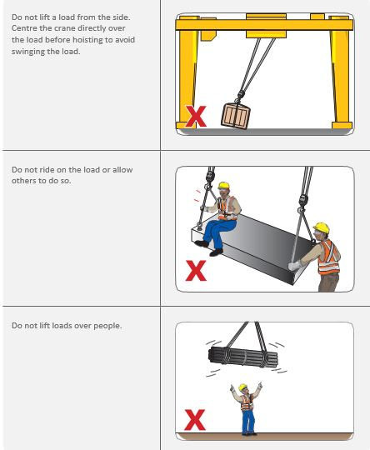

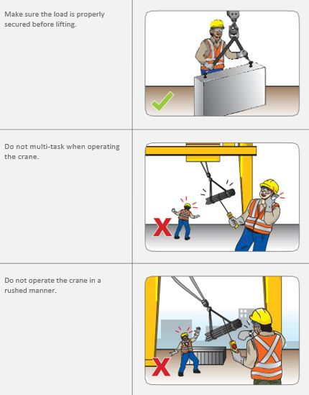

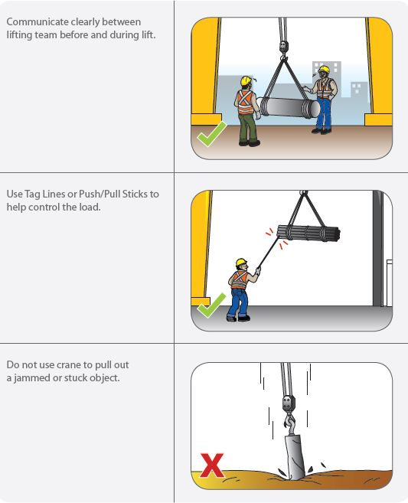

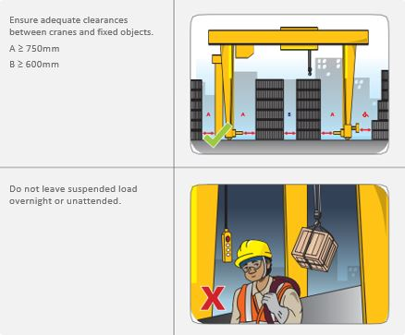
Figure 6: Safety Considerations

Tandem Lifting

When using more than one crane or with two hoists for tandem lifting operations, a competent person shall carefully plan out the operation in detail with a thorough lifting plan and emergency plans. The operation shall be carried out under proper supervision. The person supervising the operation shall fully understand the details of the operation and shall ensure that the operators understand the sequence and the hazards of the operation.

Maintenance

The employer must maintain a crane and its accessories in a condition that will not endanger an operator or another employee.

A preventive maintenance programme should be established and the programme must be based on the manufacturer’s recommendations and, for the application as reviewed by a qualified person.

Use of Special Lifting Attachments

The use of clamp, grabmagnet, and vacuum as attachments are mainly used in heavy industry for mass production and in incinerator plant for waste management. The use of such attachments is complex. Should these attachments be used, users must refer to the manufacturers’operational and safety manual.
The following are examples of lifting clamps to lift steel plate;

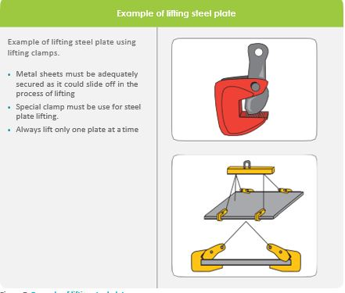
Figure 7: Special Lifting Attachments

Environmental Conditions

During outdoor operations, lifting operations can be affected by rain, thunderstorms and strong winds.

Rain
For all outdoor cranes, the equipment and all sensitive components should have been designed with the correct Ingress Protection (IP) enclosure and proper shelters.

Thunderstorms
During thunderstorms, stop lifting operations immediately.

Strong Winds
Cranes must never be used when wind speeds are beyond those recommended in the crane manufacturer’s instructions.
In the event of strong winds, stop all lifting operation and secure the gantry crane with a wind restraint device.

Documentation
The following three documents must be prepared and signed off by the supervisor before the commencement of all lifting:
- Gantry Daily Prestart Check
- Rigging Plan
- Lift Plan

The crane operator must fully understand the above documents and follow them closely. If in doubt he/she must seek help from the supervisor.

These documents are available from the Crane Association (Crane Training New Zealand Shop, 2019)

Further Information
This Position Paper contains summary information only and further information is available by contacting the Crane Association of New Zealand (Inc.)

Contact Details
Postal Address: | PO Box 12013, Wellington 6144
Physical Address: | 21 Fitzherbert Terrace, Thorndon, Wellington
Telephone: | +64 4 473 3558
Email: | info@cranes.org.nz

References
Crane Association of New Zealand Inc. (2015). Crane Safety Manual Ver 3.2. Wellington: Perception Group.
Crane Training New Zealand Shop. (2019, April 24). Home Page. Retrieved from Crane Training New Zealand Shop: https://shop.cranes.org.nz/
Department of Labour . (2009). Approved Code of Practice for Cranes 3rd Edition. Wellington: Department of Labour.
Ministry of Business, innovation and Employment. (1999). Health and Safety in Employment (Pressure Equipment, Cranes, and Pasenger Ropeways) Regulations 1999. Wellington: Ministry of Business, innovation and Employment.
Ministry of Business, Innovation and Employment. (2015, September 04). Health and Safety at Work Act 2015. Retrieved from Government Legislation: http://www.legislation.govt.nz/act/public/2015/0070/latest/DLM5976660.html

