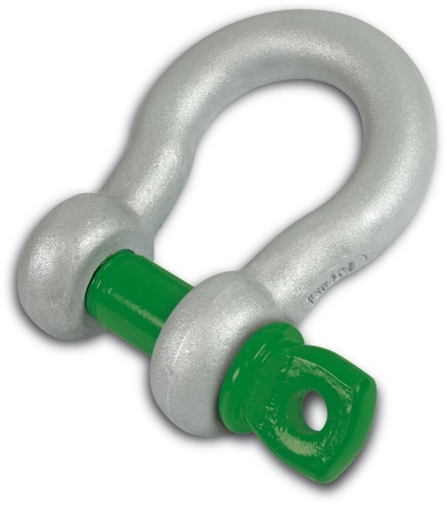

Crane Association of New Zealand
Position Paper

Shackles – Tagging and Inspection

Author: Crane Association of New Zealand
Date: 10 January 2019
CANZ PP-004-T

Document Control
File Name | CANZ-PP-004-T-Shackles-Ver1.0.docx
Document Location | CANZ Position Papers-Technical Papers
Document Status | Review issue
Version Number | Version 1.1
Issue Date | 12-11-2017
Assigned Responsibilities | Author | Scott McLeod, President
 | Reviewer | Technical Committee
 | Reviewer | CEO, Crane Association of New Zealand (Inc.)
 | Owner / Approver | Council, Crane Association of New Zealand (Inc.)
Next Review Date | NOVEMBER 2018

Record of Amendments
Version | Date Issued | Summary of Changes
Version 1.0 DRAFT | 12-08-2016 | Draft Issue
Version 1.1 Reviewed | 12-11-2017 | Review Issue
Version 1.2 | 10-01-2019 | Amend Section 5 U/S 3789

Disclaimer and Copyright
This Crane Association of New Zealand (Inc) Position Paper has been compiled for general information only, is not to be considered as a substitute for professional advice, and should not be treated as an exhaustive statement on the subject. The Crane Association of New Zealand (Inc) accepts no responsibility for the accuracy, completeness or currency of the material included in this Position Paper.
Users of this Position Paper are encouraged to obtain professional advice and to exercise their own skill and care in relation to any of its material.
The Crane association of New Zealand (Inc) disclaims any and all liability or responsibility for any loss or damages arising out of any use of, or reliance on, this Position Paper.
This Position Paper is copyright. Readers may use and reproduce this material in an unaltered form only for non-commercial use within their own organisation.

Contents
1. Crane Association Position 4
2. Codes 5
The Approved Code of Practice for Load Lifting Rigging 5
History 5
The Code of Practice for the Safe Use of Lifting Equipment published by LEENZ states: 6
3. AS 2741– Shackles 7
4. Manufacturer 8
5. NZQA US 3789 Version 8 9
6. Further Information 10
7. Images 11

Crane Association Position

It is the position of the Crane Association of New Zealand (Inc.) that:

Shackles used for the lifting of loads, for example when they are being used by a crane and are not in a permanent fixture have the following requirements:
- All shackles should be visually inspected by a responsible person before use or on a regular basis, taking into account the conditions of service. The inspection must be carried out with the shackle in a reasonably clean condition and in adequate lighting. If any of the following defects are readily visible, the shackle should be withdrawn from service and referred to a competent person.
  - Working Load Limit missing or unreadable
  - Identification missing or unreadable (Batch numbers)
  - Incorrect Pin
  - Damaged thread on pin or in a tapped eye.
  - Distorted body or pin
  - Worn body or pin
  - Nicks, gouges, cracks, corrosion.
  - Welding or heat-treated damage.
- Shackle pins in all general use situations should be hand tightened to ensure the shackle pin is securely seated to the shackle eye.
- Shackles do not require tagging and are not required to be on a lifting equipment register.
- It is good practice to record the date of purchase, make of shackle, and batch number.

Codes

The Approved Code of Practice for Load Lifting Rigging

History
The Crane Association of New Zealand (Inc.) was not consulted on the ACOP for Load Lifting Rigging 5th Edition. This has created a miss-match between industry practice and the ACOP. The following position paper has been published to provide members and the regulator guidance on the position of the Crane Association.

For Shackles the relevant parts of the ACOP for Load Lifting Rigging state:

3.1 Identification
Every lifting appliance and item of loose gear shall be clearly and permanently marked with its WLL by stamping, or where this is impracticable or not recommended, by other suitable means. Also, a unique identifying numbering system to clearly identify individual items should be used.
The Crane Association has identified that the unique identification of shackles is not practicable for all members and all situations and therefore does not support the practice.

5.3 Shackles
Shackles may be made of high-tensile steel or alloy steel. Refer to Federal Specification RR-C-271* or equivalent. Also, refer to the Load Chart (Table 13).

Shackles used for hoisting purposes must be marked with the WLL.

Shackles should be inspected for:
- mechanical damage to pin or body
- correct tensile pin fitted
- correct pin length
- wear.

5.12 Inspection
It is recommended that all lifting tackle shall be examined by a competent person on a regular basis. This should not exceed a 12-month period, depending on frequency, type of use, and environmental conditions. It is also recommended that for a heavily used tackle, proof loading should be carried out every year.

Visual inspection before and after use is a requirement.

Any proof loading shall be carried out by a competent person in accordance with the relevant standard or the manufacturer’s recommendations. Proof loading must be carried out after any repair, replacement or alteration, along with the examination by a competent person.

The Crane Association supports visual inspection prior to use of shackles. The Crane Association does not support proof loading of shackles.

5.13 Register
A register should be kept for lifting tackle, but this is not required for flat web, round slings, wire rope slings, or shackles. An example of this register is shown in Table 17. The register should show the date of the last recorded examination or test, and any alterations.

The Crane Association agrees that shackles should not be on a register as this is not practicable for all members.

The Code of Practice for the Safe Use of Lifting Equipment published by LEENZ states:

8.0 In-Service Inspection
In addition to the thorough examination necessary under legal requirements, all shackles should be visually inspected by a responsible person prior to use or on a regular basis, taking into account the conditions of service. The inspection must be carried out with the shackle in a reasonably clean condition and in adequate lighting. If any of the following defects are readily visible, the shackle should be withdrawn from service and referred to a competent person.
- Working Load Limit missing or unreadable
- Identification missing or unreadable
- Incorrect Pin
- Damaged thread on a pin or in a tapped eye.
- Distorted body or pin
- Worn body or pin
- Nicks, gouges, cracks, corrosion.

The Crane Association does not support the unique identification of shackles. The unique identification of shackles is not practicable for all members. The Crane Association supports that Batch numbers for identification should not be missing and should be readable as produced by the manufacturer.

The Crane Association does not support the tagging of shackles.

AS 2741– Shackles

B1 INSPECTION

B1.1 Before use

Before use, shackles should be inspected to ensure the following apply:

- The markings are legible.
- The pin is of the correct type.
- The threads of the pin and the body are undamaged.
- The body and the pin are not distorted.
- The body and the pin are not unduly worn.
- The body and the pin are free from nicks, gouges, cracks and corrosion.

B1.2 Periodic

Shackles in use should be subject to periodic thorough examination by a competent person.
The period between such examinations will depend on the amount of use.

The Crane Association agrees with the Inspection criteria and requirements of AS 2741 Section B1.

B3 ASSEMBLY
When assembling a shackle, the following requirements apply:
- Ensure that the pin is of the correct length, so that it penetrates the full depth of the screwed eye and allows the collar of the pin to bed on the surface of the drilled eye.
- Ensure that the pin is screwed securely into the shackle body, so that the collar of the pin is seated on the shackle body.
- Incorrect seating of a pin may be due to a bent pin, a tightly fitting thread or misalignment of the pin holes. Such a shackle shall be withdrawn from service.
- Never replace a shackle pin with one of a different grade or specification, as it may not be suitable for the loads imposed.
- Shackles permanently attached to a lifting device shall have their pins secured, to
- prevent unintended release, such as by seizing or mousing. Bolt and nut type pins,
- such as those shown in Figures E5 and E8, are commonly used for this purpose.

The Crane Association agrees with the assembly criteria of AS 2741.

Manufacturer
Green Pin Shackles – Van Beest

Inspection
Shackles must be regularly inspected by the safety standards given in the country of use. This is required because the products in use may be affected by wear, misuse, overloading, etc. which may lead to deformation and alteration of the material structure.
The inspection should take place at least every six months and more frequently when the shackles are used in severe operating conditions.

The Crane Association agrees with the Manufacturer by supporting prior to use inspection as the most effective form of inspection.

Instructions for use
Select the correct type and WLL of shackle and WLL for the particular application. If extreme circumstances or shock loading may occur, this must be well taken into account when selecting the correct shackle. Please note that commercial shackles are not to be used for lifting applications.
Shackles should be inspected before use to ensure that:
all markings are legible;
- the body and pin are both of the same brand and types;
- the body and pin are both of the correct sizes;
- never use a safety bolt type shackle without using a securing pin;
- the pin, nut, cotter pin, or any other locking system cannot vibrate out of position;
- the threads of the pin and the body are undamaged;
- the body and the pin are not distorted or unduly worn;
- the body and pin are free from nicks, gouges, cracks and corrosion;
- shackles may not be heat treated as this may affect their WLL;
- never modify, repair or reshape a shackle by machining, welding, heating or bending as this will affect the WLL

Assembly
Ensure that the pin is correctly screwed into the shackle eye, i.e. tighten hand-tight, then secure using a wrench or other suitable tool so that the collar of the pin is fully seated on the shackle eye. Ensure that the pin is of the correct length so that it penetrates the full depth of the screwed eye and allows the collar of the pin to seat on the surface of the shackle eye.

The Crane Association agrees with the Manufacturer to hand tighten. The Crane Association does not support the use of a wrench.

NZQA US 3789 Version 9

Outcome 1
Apply knowledge of risk management, hazard control, and rigging planning to slinging regular loads.

Performance Criteria
1.1 Identify, implement, and document controls to lower the risk for site specific hazards and foreseeable hazards.
Range may include but is not limited to – vehicles; equipment; ground condition; underground services; power sources; overhead service lines; trees, buildings, and structures; unauthorised people; adverse weather conditions; simultaneous operations; hazards to the environment; pinch points.

1.2 Identify and implement controls to lower the risk relating to foreseeable load hazards.
Range includes – risk to people, load, equipment, environment;
may also include but is not limited to – failure of lifting points/load, sharp edges, regular and irregular load differences, load support, loose objects on the load, hazardous goods, load security, effects of weather, structural strength of the load.

1.3 Explain the rigging plan, appropriate to the load, in relation to the people involved and people in the area of operations.
The Crane Association supports US 3789 which incorporates inspection prior to use.

Further Information
This Position Paper contains summary information only and further information is available by contacting the Crane Association of New Zealand (Inc.)

Contact Details
Postal Address: | PO Box 12013, Wellington 6144
Physical Address: | 21 Fitzherbert Terrace, Thorndon, Wellington
Telephone: | +64 4 473 3558
Email: | info@cranes.org.nz

Crane Association of New Zealand (Inc)
higher standards - safety first

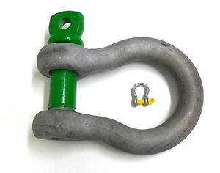
Images

