the CANZ Crane Competence Scheme (CCCNZ)

What is CCCNZ?
CCCNZ will be recognised by the Crane Association of New Zealand Incorporated, WorkSafe and the New Zealand Construction Safety Council, amongst others, as the preferred Certificate of Competence to comply with codes of practice for competence and certification.
It will be launched in 2019 to help employers comply with regulations and requirements and aims to apply common standards for all crane operators.
CCCNZ is owned by the Crane Association of New Zealand (otherwise known as CANZ) which allocates staff to manage and administer it on behalf of the CANZ Crane Council that develops its policy and strategy.

What are the aims of CCCNZ?
CCCNZ aims to:
- Provide identification for crane operators and Dogmen and those involved with crane operations by recognising skills, knowledge and understanding competence and qualifications
- Raise health, safety and environmental standards through a programme of health, safety and environment testing to prove workers have met the minimum standard.
- Provide standards of learning and assessment to equip individuals with relevant skills and knowledge to seek employment within the crane industry
- Provide or improve employment prospects for individuals and experienced operators
- Keep a record of workers in the crane and allied industries who have achieved a recognised level of operating ability and competence, and to provide a means of identification
- Be self-financing, with any surplus funds being used for continuous development of the programme and to be used for the benefit of the crane industry
- Encourage crane and allied employers to use certificated and competent operators
- Provide certification that could be accepted and recognised through agreements with other countries.

Core Elements of the Scheme
CCCNZ is made up of some core elements, which are used to demonstrate skills, competence and qualifications that determine eligibility for certification.
- Training – through a variety of channels
  - Skills contract trainer/assessors
  - Skills employment trainer/assessors
  - Private Training Establishments
  - Polytechnics
  - Other ITO trainer/assessors
- New Zealand Qualifications – operating competence and vocational qualification
- Constructsafe Theory Test – Online test underpinning knowledge and understanding
- Constructsafe Practical Test – assesses the operating ability
- Logbook – the on-going operating ability
- Constructsafe Renewal Test – up to date knowledge and understanding

Certificate of competency confirmation
Confirmation of licencing will be done through the Crane Operator online register that will stipulate qualifications and licencing level. The register will be publicly accessible for agencies, crane companies, and construction principals.

Delivery of the Scheme
The Scheme will be delivered through accredited test centres; for example
ConstructSafe Tier 1
ConstructSafe Tier 2 Test supplied by CANZ delivered through ConstructSafe
ConstructSafe Tier 2 Practical test to be assessed by approved Assessors
Renewal To be determined

Routes of Entry
There are three routes of entry into the Scheme which will lead to the attainment of a Competent Operator Licence
The three routes of entry are:
- Direct to Competent Operator
- Through Trained Operator to Competent Operator (a two-stage process)
- Overseas operators on Work Visas that demonstrate on the job experience (period to be determined) and hold a qualification or licence from their country of origin.

Relationship to Qualifications
- New Zealand Certificate in Crane Operations Level 3 (Truck Loader Crane, Cab-Controlled Overhead Crane, Remote Controlled Overhead Crane and Self Erecting Tower Crane)
- New Zealand Certificate in Dogman Operations Level 4
- New Zealand Certificate in Crane Operations Level 4 (Mobile, Crawler, Non-Slewing Articulated Crane, Self-Erecting Tower Crane, and Mini-Crawler Crane.
- New Zealand Certificate in Advanced Crane Operations Level 5 (Piling and Foundation, Advanced Crane Operations, Crane Supervision, and Crane Dispatch Supervision.

Trained Operator
The Trained Operator confirms a level of core skills, knowledge and understanding that can be applied in the workplace until measured as competent against national standards.
Experienced and able operators may hold a Trained Operator Licence while being measured against the New Zealand Certificate in Crane Operations.
The Trained Operator Licence is valid for four-years and is non-renewable. This Licence is issued on completion of an individual crane operation unit standard(s) or the New Zealand Qualification in Crane Operations, whichever is the required minimum standard.
The requirements for this licence are:
- Carry out any training necessary to bring the operator up to the standard required to enable them to pass the CANZ Technical Test (this can be delivered by a trainer).
- Achieve the ConstructSafe Health and Safety Tier 1 test
- Achieve the ConstructSafe Tier 2 Theory Test
- Achieve the ConstructSafe Tier 2 Practical Assessment (within six months of the Tier 2 theory test)
- The theory test is delivered by an accredited test centre.
- The practical assessment is delivered by an appointed assessor.
- On achievement of the practical test, the online register will be updated with the operators new licencing details.

Exceptions for Existing Licence Holders
Exceptions are available for existing licence holders (current/expired) where under some circumstances individuals are unable to progress. Those exceptions are
- 12-month extension to complete the New Zealand Qualification
  - Must hold a valid Trained Operator Licence which is still within the 12 month grace period
  - Must be registered for the New Zealand Certificate in Crane Operations
- Receive an additional two-year Licence
  - Must hold an expired trained operator licence which is outside of the 12 month grace period
  - Achieve the ConstructSafe Tier 2 theory test
  - Achieve the ConstructSafe Tier 2 practical test (within six months of achieving the ConstructSafe Tier 1 theory test)
  - Is registered or can get registered for the New Zealand Certificate in Crane Operations

Appeal
An individual can appeal for exceptional circumstances if they fall outside of the criteria above. The appeal process can be found in the CANZ Booklet for Operators.

Competent Operator
The Competent Operator Licence tells the employer, regulators, or other interested parties that the holder has demonstrated a level of health and safety awareness through the Constructsafe test. They must have an underpinning knowledge gained through a ConstructSafe Tier 2 theory test, have the operating ability previously gained through a ConstructSafe Tier 2 practical test and shows operating competence on a designated crane (evidenced by a New Zealand Qualification or employer confirmation of competence reinforced by a completed logbook(s).
The Competent Operator Licence is renewable every four years. The following describes the pathway to achieving the Competent Operator Licence.

Moving from a Trained Operator to a Competent Operator
The requirements to move from Trained Operator to Competent Operator are as follows:
- Achieve the ConstructSafe Tier One health and Safety test
- Hold a valid Trained Operator Licence that must be within the 12-month grace period
- Achieve the ConstructSafe Tier 2 theory test
- Achieve the ConstructSafe Tier 2 practical assessment
- Achieve a New Zealand Certificate in Crane Operations
- Apply for a licence upgrade.

Working Directly Towards a Competent Operator Licence
The requirements to obtain this licence are to:
- Provide proof of achievement of the New Zealand Certificate in Crane Operations and provide this information to the accredited Assessor upon undertaking the ConstructSafe practical assessment
  - Achieve the ConstructSafe Tier 2 Theory Test (within 12 months of achieving the ConstructSafe Tier 1 health and safety test)
  - Achieve the ConstructSafe practical test (within six months of achieving the ConstructSafe Tier 2 theory test)
- The theory tests are delivered by an accredited ConstructSafe Test Centre, and practical tests are delivered by an approved assessor.
On achievement of the practical test, the online register will be updated with the operators new licencing details.
On receipt of your first Competent Operator Licence, you will be sent a CANZ Logbook. The role of the Logbook is to record life-long learning and evidence towards the renewal of a Competent Operator Licence.

Adding More Qualifications and/OR Endorsements
If you want to add new categories or further endorsements, you are required to (in this order):
- Provide proof of achievement of the New Zealand Certificate in Crane Operations and provide this to the Assessor upon undertaking the practical test
- Achieve the practical test (within six months of the theory test and within 12 months of the Constructsafe Tier 1, Health and Safety test).
- Dependant on category/endorsement being added you may be required to achieve the Tier 2 theory test (within 12 months of the Tier 1 health and safety test).
- On achievement of the practical test, the online register will be updated with the operators new licencing details.

Exceptions for existing Competent Operator Licence holders (current/or expired)

CANZ acknowledges that some individuals may be unable to progress and the following additional pathways are therefore available:

Temporary Competent Operator Licence
The requirements to obtain this Licence are:
- Demonstrate on-going practical operating experience through a choice of routes:
  - Logbook
  - On-Site Assessment
  - Practical Test
  - New Zealand Certificate in Crane Operations
- Hold a valid Competent Operator Licence

Return to Work route
The requirements for this route are to make an Out of Work Declaration by:
- Contacting the CANZ Helpline on 04 473-3558, where you confirm you are currently out of work.
- A confirmation letter will be issued, which can be shown to potential employers outlining the steps required by you to enable you to return to full Scheme Membership, along with the appropriate application form.
When you have found employment, you can then apply for a six-month temporary Licence. To obtain this Licence you need:
- A valid, relevant Tier 1 health and safety test pass (within two years of the date of application receipt)
- On achievement of the requirements, you will need to complete the Application for a Return to work six-month licence issue. This can be found on the reverse of the confirmation letter
Once you have obtained your six-month temporary licence, you can fully re-enter the scheme (at the same level previously held) by applying for a renewal of your Competent Operator Licence.

Logbook
The role of the Logbook is to record life-long learning and evidence towards the renewal of a Competent Operator Licence.
The use of the Logbook is voluntary and the cheapest option to use for renewing a Competent Operator Licence; however, it is only one route to providing on-going operating experience at the point of renewal.
CANZ recommends that the Logbook be used to keep a record of all the operating activities, testing, training and employment that the individual undertakes.
A Logbook is automatically sent out once the individual’s first Competent Operator Licence is issued. The Logbook is sent to the individual's home address.
If you renew your Competent Operator Licence using the logbook route, then you should have the Logbook validated before submission of your application. This would be performed by a company-approved Validator. They will review the Logbook before completing the Independent declaration section of the renewal application

How to complete your logbook:
The Logbook is divided into five sections with the first four sections providing records for different aspects of the individual’s career to be logged and endorsed:
- Section 1: Operating Experience Record - endorsed by Supervisor
- Section 2: Testing Record - endorsed by ConstructSafe Tester
- Section 3: Training Record - endorsed by Trainer/Assessor
- Section 4: Employment Record - endorsed by Employer
- Section 5: Further information
If you wish to use the Logbook to prove on-going operating experience at the point of renewal, the following steps must be followed:
- Record your operating hours
- Entries must be endorsed.
- Minimum of 300 hours should be recorded
- Must be validated by the company before a renewal application being submitted.

Restricted Operator Licence
The Restricted Operator Licence tells the employer, regulators, or other interested parties that the holder has demonstrated a level of health and safety awareness through the ConstructSafe test. He or she has an underpinning knowledge gained through recognition of prior learning, has the operating ability previously gained through recognised on the job experience and showing operating competence on a designated crane (evidenced by an international qualification or licence and has an overseas employer confirmation of competence), and holds a relevant work visa.
The Restricted Operator Licence can be renewed for a further two years and expires with the relevant fixed-term work visa the operator holds. If the operator becomes a permanent New Zealand resident, they will not be eligible for a renewal and will have to complete a blended assessment process (map NZ qualification to overseas qualification or licence (RPL) and complete the theory and practical tests.
The requirements to hold this Licence are:
- Holds a relevant fixed-term work visa
- Provide proof of overseas qualification or licence
- Complete the ConstructSafe Tier 1 health and safety test
Each application is evaluated on its own merits and must be supported by CV’s, an employer’s confirmation of competence and proof of overseas qualifications or licence. As an example, the following table shows how an overseas qualification would align with the corresponding New Zealand qualification for a Dogman.
This mapping process is currently being conducted on the plumbing trade by Skills which could be adapted into a template that would be applied to crane operators and dogman.

Rigging and Dogman Crossover

Overseas Qualification | NZ CoC Level
UK CPCS A-40 Slinger/Signaller. Must hold a current Trained Operator Licence | Slinger (Trained Operator) CoC
UK CPCS A-40 Slinger/Signaller. Must hold a current Competent Operator Licence | Dogman (Competent Operator) CoC
Aust CPCCLDG3001a – licence to perform dogging (Basic Rigging HRW) | Slinger (Trained Operator) CoC
Aust CPCCLDG3001a – licence to perform dogging (Intermediate Rigging HRW) | Dogman (Competent Operator) CoC
Ireland CSCS/QQISlinger Signaller (Banksman)  FETAC Certificate and CSCS Licence Holder | Dogman (Competent Operator) CoC
USA Basic Rigger NCCCO Rigger Level 1 | Slinger (Trained Operator) CoC
USA Advanced Rigger NCCCO Level 2 | Dogman (Competent Operator) CoC

The following table represents the requirements for Riggers and Dogman to achieve a Certificate of Competency (Licence).

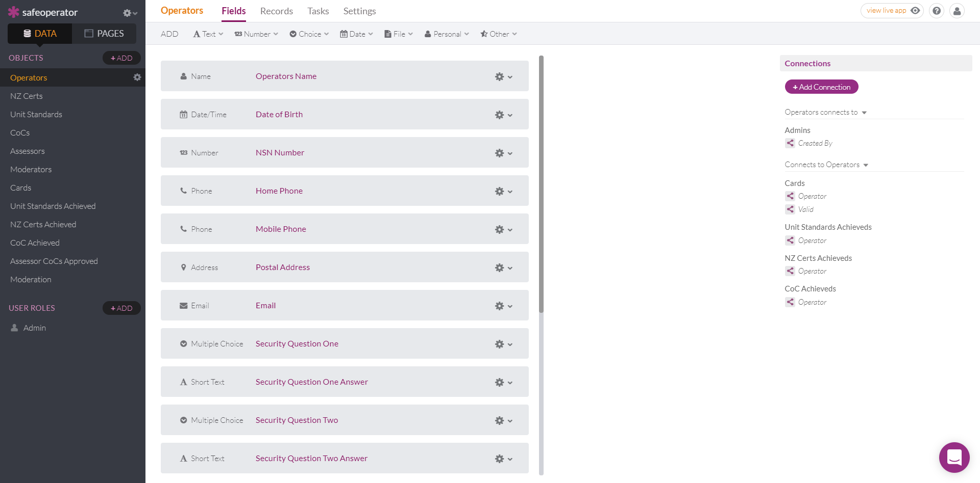
The following is an example of a potential register that could be added to the website in the same manner as the crane directory. Login security would be added so that regulators and crane companies could access it to view and for ConstructSafe. Test Centres and practical test assessors could add data for individuals completing the various test requirements.

Summary
The concept outlined is one potential pathway that CANZ can adapt to enable licencing of crane operators and dogman.
CANZ would develop the framework and structure for the Tier 2 theory and practical tests and this would plug into the ConstructSafe testing regime. Currently we don’t have the resources to set up and administer a separate entity.
Skills are templating a Recognition of Prior Learning process, we should recognise that this could potentially be adapted for the crane industry.
If we have a licencing process in place before the amendments to the ACOP for Cranes and the PECPR 1999 are submitted, then potentially we could have the licencing incorporated as a requirement for all Crane and Dogman Operators.
If we do not go through this process, we may find that the Regulator will force it upon us and/or give to someone else to manage.

Recommendation
It is recommended that the Education Subcommittee urgently review the licencing process with an aim to report back to the Council to provide a way forward

Rod Auton
CEO

The term “operator” includes dogman

